What is Faculty180 Dossier?
Dossier is a feature accessible in Faculty180 for document storage. The documents and resources stored in Dossier are available within the Faculty180 Reviews module when faculty are building their PAD documentation for promotion and tenure processes. Faculty can begin storing documents in Dossier at any time. Navigate to the module by logging in to Faculty 180, clicking on your name in the top right-hand corner and choosing “Interfolio Dossier.”
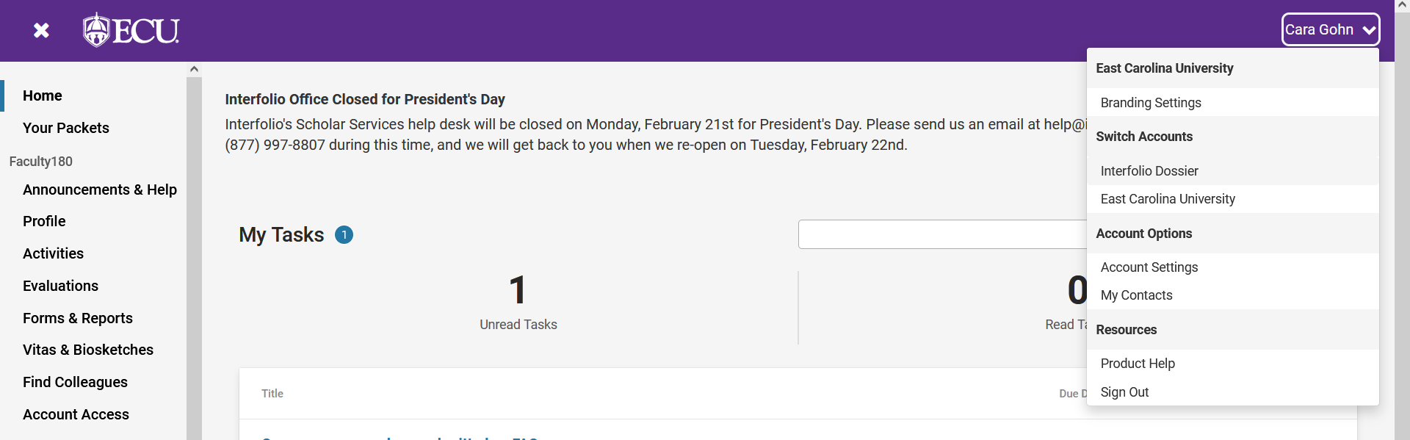

Documents in Dossier can be stored in the “Materials” menu, or groups of related documents can be stored in the “Collections” menu. “Collections” are intended to contain related documents and can be named using any naming convention chosen by the faculty member. Faculty can use the “Letters” menu to store recommendation letters.
Documents added to the “Materials” menu can be tagged with categories like “Teaching,” “Scholarship,” etc. Those tags may be helpful when organizing documents into Collections.
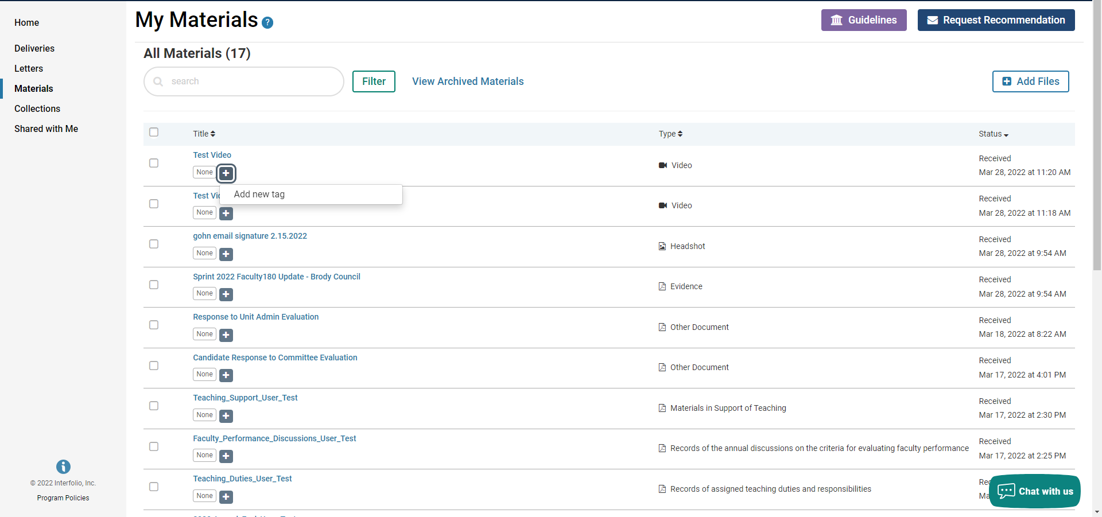

Documents already uploaded in the “Materials” menu can be sorted in to new or existing collections by selecting the document(s), clicking “Add To,” and choosing or creating a collection.
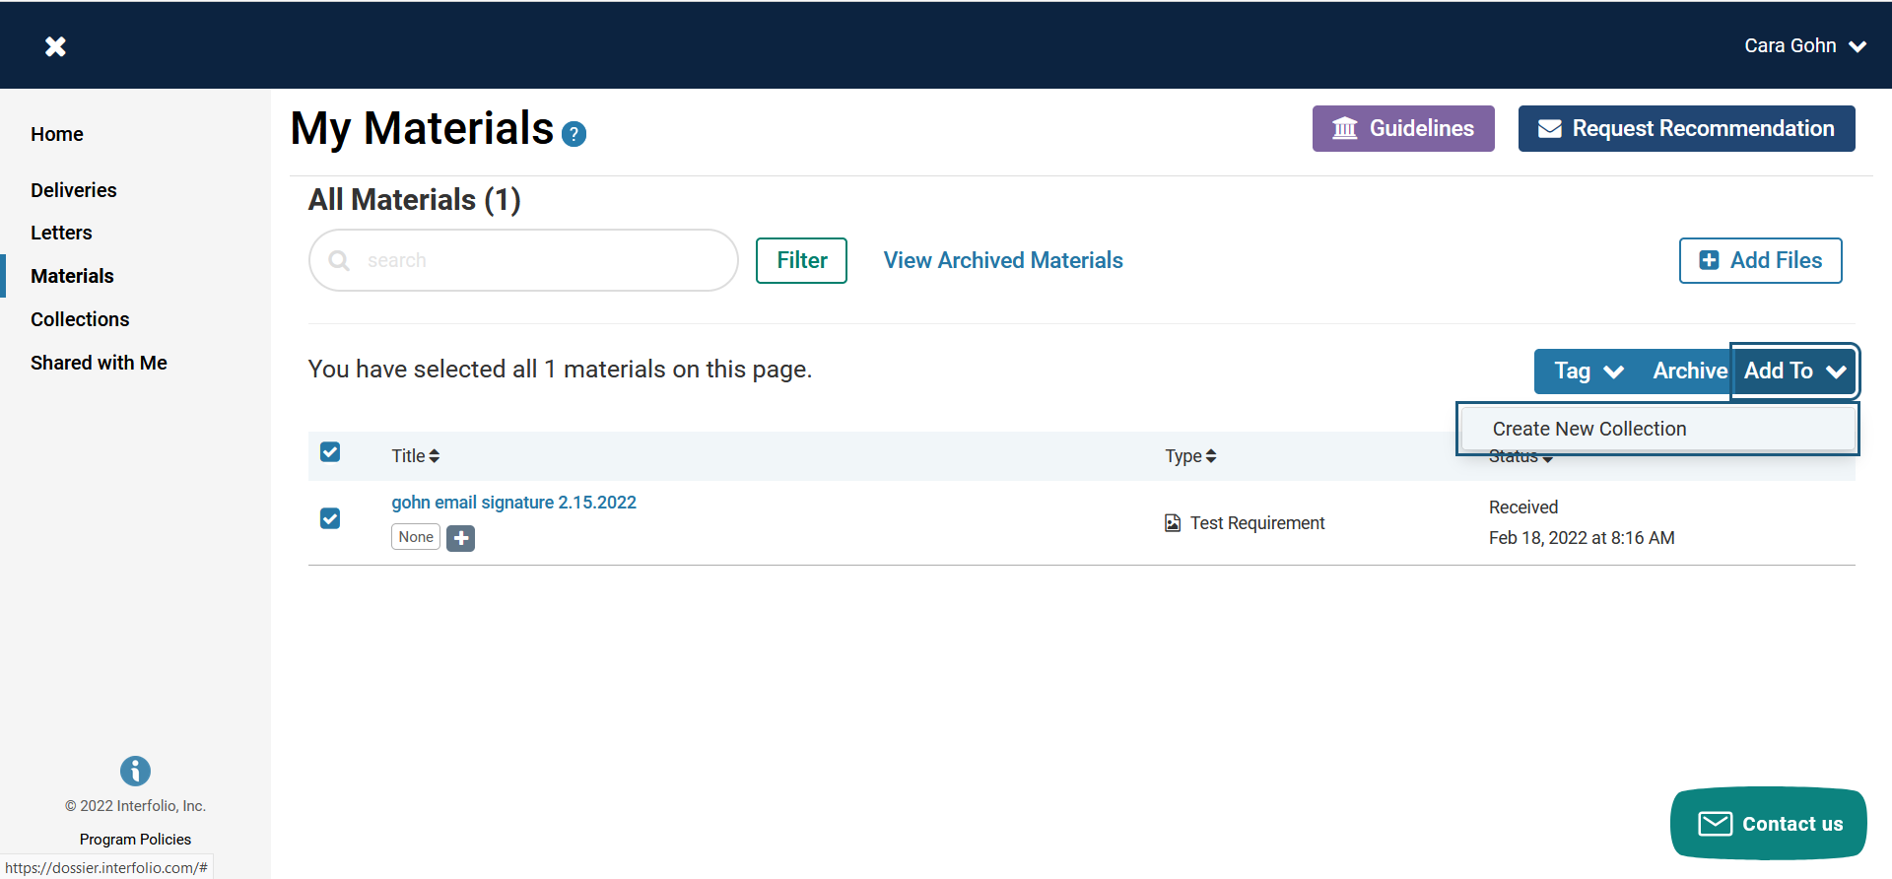
Candidates can share collections of materials with any other Faculty180 user. In the “Collections” tab click on the “Select” button to the far right and choose “Share.”
The person in which you shared the collection will receive an email and the documents will appear in their “Shared with Me” menu in Dossier.
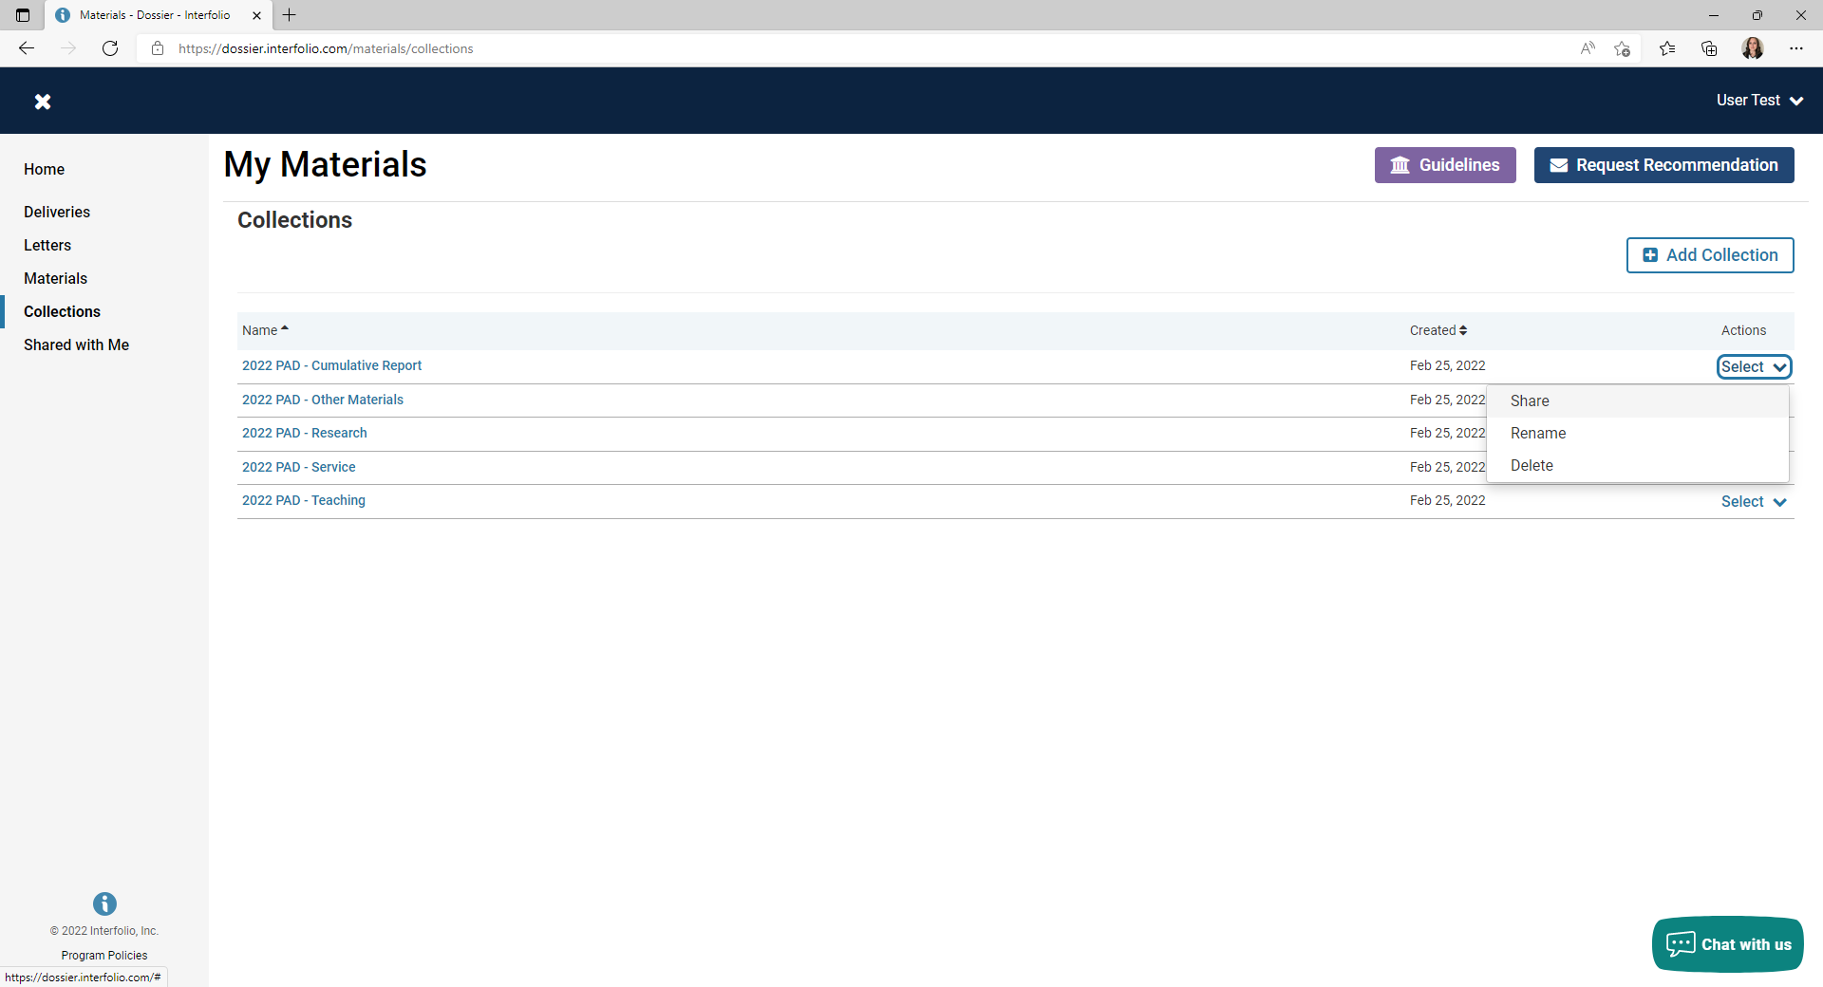

Navigate back to Faculty 180 by clicking on your name and selecting “East Carolina University.”
